SOMATIC-ORA
Digital immunity, engineered
A Concept and Roadmap Proposal for a Pilot Partner
Submitted by Nature
September 2026

Why This, Why Now
In March 2026, CABS — a Zimbabwean bank — discovered that a former IT intern had installed unauthorized remote-access software on a company-issued laptop during a November 2025 internship, and used it to generate 1,911 fraudulent ZIPIT transactions plus fraudulent VISA transactions, totaling roughly US$1.1 million. The breach wasn't caught by anything inside the bank's own systems — it was flagged by VISA noticing unusual ATM activity from the outside. That gap is the entire case for this proposal in miniature: a piece of software that didn't belong was running quietly for months, and the pattern of many individually small, plausible transactions was exactly the kind of thing a signature-based tool is built to miss and a behavioral one is built to catch.
The same period has seen a steady rise in fraud against ordinary mobile-money and messaging-app users — scams built around EcoCash and WhatsApp accounts, using phishing links and social engineering to extract one-time PINs. That pattern is different in kind from the CABS case (it targets people, not systems directly) and is exactly why the mobile-fraud-monitor environment in Section 3.3 exists as its own layer rather than an afterthought.
Zimbabwe already has a legal framework built for this: the Cyber and Data Protection Act [Chapter 12:07] defines unauthorized access, system interference, and related offenses. What's largely missing isn't law, it's tooling that produces the kind of clear, contemporaneous record of what happened and how that makes those laws enforceable in practice — which is precisely what the learning-loop output in Section 5 is designed to be.

1. The Concept, in Plain Terms
SOMATIC-ORA is a network of small, lightweight software watchers — call them agents — spread across a system instead of relying on one central firewall or dashboard. Each agent is built to blend in with normal background activity rather than announce itself, the same way a white blood cell doesn't look different from the tissue around it until it's needed.
Each agent constantly learns what "normal" looks like for the small part of the system it watches. When something doesn't match — a pattern of behavior that looks foreign rather than familiar — the agent can act immediately to contain it, and then it reports back two things: what happened, and how it got in far enough to be noticed at all. That second part is the piece most security tools skip. A typical tool tells you that you were attacked; this is meant to also tell you why your defenses let it get that far, in language a non-technical system owner can act on.
The name comes from that idea directly: "somatic" means "of the body," and the system is meant to behave the way a body's own defenses do — distributed, self-monitoring, and self-correcting — rather than as a single gatekeeper standing at one door.
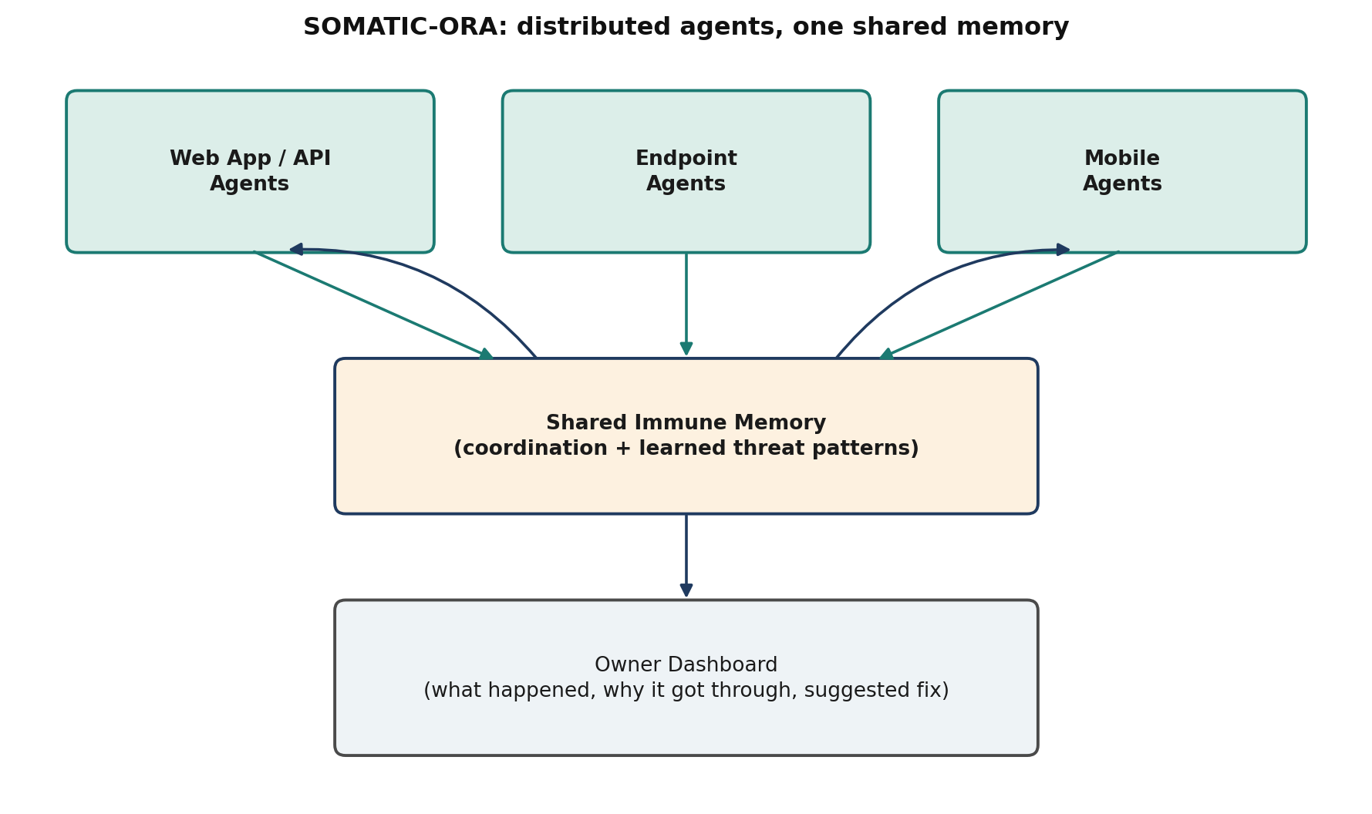
The diagram above is the whole architecture in one picture: agents sit in three environments where real attacks actually happen, they all feed what they learn into one shared memory layer, and that shared layer both makes every agent smarter over time and produces the plain-language report a system owner actually reads.

2. The Biological Model, Mapped Directly to Security
Every mechanism in SOMATIC-ORA has a specific, deliberate counterpart in how the human immune system actually works — this isn't a loose metaphor used for branding, it's the design method. The table below is the working reference used throughout the rest of this document.
Immune system concept | Security equivalent in SOMATIC-ORA
Skin and mucous barriers — the body's first, physical line of defense | Perimeter controls: login checks, input validation, rate limits at the door
Innate immune system — fast, general-purpose responders (e.g. white blood cells) that act within minutes, without needing to have seen a threat before | Tier-1 agents: rule-based blocking of known-bad patterns (brute-force attempts, malformed requests, known malware signatures) — immediate, no learning required
An antigen — a marker on a pathogen that the body learns to recognize | A behavior fingerprint: a specific pattern of code, traffic, or activity that marks something as an intrusion
An antibody — a molecule shaped to recognize and neutralize one specific antigen | An agent tuned to recognize one class of attack behavior and act on it directly, wherever it appears
Self vs. non-self recognition — distinguishing the body's own cells from foreign material | Baseline behavior modeling: learning what 'normal' looks like for a given system so anything else stands out
Adaptive immune response — T-cells and B-cells that learn and refine their response to a specific threat over the course of an infection | The learning loop: agents refine their detection rules based on what they observe, catching attacks that don't match any known signature
Immune memory — the reason a second infection by the same pathogen is fought off faster | Shared threat-pattern database: once one agent learns a pattern, every agent benefits from it immediately
Cytokine signaling — cells alerting each other and coordinating a response | Agent-to-agent communication: an agent that detects something warns the rest of the network
Inflammation — a contained, localized response around the affected tissue | Scoped containment: the affected component is isolated or blocked without shutting down the whole system
Autoimmune disease — the immune system mistakenly attacking healthy tissue | False positives: the central design risk of any autonomous-blocking system, addressed directly in the response-tiering below

3. Where the Agents Live: Three Environments
For a pilot partner, the practical question is which of these three environments matches your own exposure — a financial institution's natural starting point is the web/API layer given the CABS case above, while a mobile network operator or fintech would more likely start with the mobile fraud-monitor layer.

3.1 Web application / API shield
Agents sit as middleware in front of and inside a web application or its backend API — the layer that handles logins, payments, and administrative functions. They watch for the two attack shapes that account for most real breaches: brute-force and credential-stuffing attempts against login and admin endpoints, and malicious input designed to manipulate a database or a server (injection-style attacks). A high volume of repeated probing against an administrative route, for example, is one of the most common and most telling signs of an attack in progress, and is exactly the kind of pattern a tier-1 agent is built to catch and throttle automatically, before it becomes a full breach.

3.2 Endpoint / server protection
Agents run on individual devices, servers, and cloud workloads, watching three things continuously: whether critical system files are being changed by something that shouldn't be touching them, whether the machine is making outbound network connections to unfamiliar destinations (a common sign of a remote-access tool operating without authorization), and whether login attempts — remote or local — show a pattern of probing rather than a legitimate user simply mistyping a password.

3.3 Mobile / end-user fraud monitor
Agents (or a lightweight companion app) watch for the social-engineering patterns that target individual users directly: phishing links sent by SMS or messaging apps, impersonation of a bank or mobile-money provider, and requests for a one-time PIN dressed up as a routine security step. This is the layer aimed squarely at the fraud pattern used against mobile money and messaging-app accounts, where the "attack" is really a conversation designed to trick a person rather than a technical exploit of a machine.

3.4 Why all three, and why one shared memory
These three environments are deliberately treated as one system rather than three separate products, because real attacks often cross between them — a phishing message (mobile layer) harvests a credential that is then used to probe a login endpoint (web layer) from a compromised device (endpoint layer). A pattern learned in one environment should immediately sharpen detection in the other two. That is the job of the shared immune-memory layer in the diagram above: it is the system's long-term memory, in the same sense that immune memory is what makes a second exposure to a pathogen faster to fight off than the first.

4. How Detection and Response Actually Work

4.1 Two tiers, mirroring innate and adaptive immunity
Tier 1 is fast and rule-based, modeled on the innate immune system's non-specific, immediate responders: it recognizes known-bad patterns (a known malware signature, an obvious brute-force pattern, a request that matches a known attack technique) and can act on them within moments, without needing to have learned anything about this specific system first.
Tier 2 is slower and behavioral, modeled on the adaptive immune system: it learns what normal activity looks like for this particular system, this particular user base, this particular pattern of traffic — and flags or contains activity that deviates from that learned baseline, even when it doesn't match any known signature. This is the tier that catches genuinely novel attacks, including the kind carried out by a trusted insider using legitimate-looking tools in an abnormal way, which by definition won't match a known "bad signature" but will look statistically strange against the system's own history.

4.2 A graduated response, not an on/off switch
Autonomous blocking is only trustworthy if it fails safely, so response is deliberately graduated rather than immediate and total: observe quietly first, then throttle or slow the suspicious activity, then quarantine the specific account, connection, or process involved, and only escalate to a full block once confidence is high or the pattern matches a well-established known threat. This mirrors how inflammation in the body is a contained, local response around the affected area rather than a system-wide shutdown, and it is the direct design answer to the biggest risk in this whole approach: a system that blocks legitimate activity by mistake (the "autoimmune" failure mode) teaches its own operators to distrust and eventually disable it.

5. The Learning Loop: Turning an Incident Into a Fix
Once an intrusion is contained, the same event triggers a second process: working backward through what happened to identify the specific gap that let it get as far as it did — a credential that should have been revoked, a port that shouldn't have been open, a permission that was broader than it needed to be. That reconstruction is turned into a plain-language recommendation for the system's owner, not a raw technical log, because the goal is a fix that actually gets made, not just a record that an event occurred.
That lesson is then written into the shared threat-pattern memory described in Section 3.4, so every other agent in the network — regardless of which of the three environments it lives in — carries the improved detection forward automatically. This is the direct equivalent of immune memory: the specific value isn't that one infection was fought off, it's that the whole system is measurably better prepared for the next one.

6. Prior Art and What's Actually New Here
This is not the first time security research has borrowed from immunology. "Artificial Immune Systems" is an established academic field going back to the 1990s, applying concepts like self/non-self discrimination and negative selection to intrusion detection. And at least one well-known commercial product, Darktrace, built its early reputation on an "Enterprise Immune System" framing for anomaly-based network detection — though its current public positioning (checked as of this document's writing) has moved toward describing itself as "Adaptive AI" and a "Behavioral Defense Platform," rather than leading with the biological metaphor.
So the honest claim here is not "nobody has thought of immune-system-inspired security before." It is narrower and more specific: the combination of (a) camouflaged, distributed agents rather than a centralized analysis platform, (b) a first-class output that is a plain-language root-cause explanation and hardening suggestion, not just an alert, and (c) one shared learning layer spanning web, endpoint, and mobile environments uniformly, is not the way the existing academic or commercial work in this space is structured. Any next step toward a patent filing would need a proper prior-art search by someone qualified to do one — this section is a starting map of that landscape, not a substitute for it.

7. Legal and Regulatory Fit (Zimbabwe)
Zimbabwe already addresses unauthorized computer access, data tampering, and related offenses through the Cyber and Data Protection Act [Chapter 12:07], rather than through a separate, standalone "Cyber Crimes Act" (a distinction worth being precise about, since the latter is a frequent subject of online misinformation). This matters directly for SOMATIC-ORA's design: the detailed, timestamped incident reconstruction produced by the learning loop in Section 5 is exactly the kind of contemporaneous record that gives an existing offense under that Act something concrete to be enforced against, rather than requiring new legislation to be useful.
There is also an existing local ecosystem this could plug into rather than needing to build from nothing: institutions such as Trust Academy Harare and the Institute of Cyber Security Zimbabwe already train ethical hackers and penetration testers for local corporate and financial networks, and are a plausible source of pilot feedback, validation, or collaboration as this moves from concept to prototype.

8. Roadmap
The roadmap below describes a phased path to a scoped, low-stakes pilot rather than a full deployment — no budget is attached at this stage, since the near-term ask is evaluation and collaboration, not funding.
Phase | Focus | What 'done' looks like
Phase 0 — Foundation | Build the attacker-technique knowledge base (the "antigen library") that agents are trained against, and define the baseline-behavior model for one environment | A documented set of attack patterns per environment, and a working prototype that can tell normal from abnormal behavior in a controlled test
Phase 1 — Single-environment prototype | Build and test one agent type end-to-end (detect, contain, report) in a single environment before expanding | One agent type reliably blocks a known attack pattern in a test environment and produces a plain-language incident report
Phase 2 — Multi-environment expansion | Extend the same core engine to the other two environments and build the shared threat-pattern layer connecting them | All three agent types share detections; something learned in one environment improves detection in the others
Phase 3 — Controlled pilot | Run the system against real (but low-stakes or consented) traffic to measure false-positive rate and refine response tiering | A measured false-positive rate low enough to trust autonomous blocking, plus a track record of correctly explained incidents
Phase 4 — Hardening & scale | Address agent security itself (agents must not become a new attack surface), formalize the response-tiering policy, and prepare for wider deployment | Agents pass their own security review; response actions are auditable and explainable to a non-technical system owner

9. Risks and Open Questions
A concept like this is only credible if its failure modes are named up front rather than discovered later. These are the ones that most directly shape the design decisions above, and remain open engineering questions rather than solved problems.
Risk | How it's addressed / what remains open
False positives (the "autoimmune" risk) | An agent that blocks legitimate activity by mistake erodes trust fast — worse than missing an attack, because it teaches operators to disable the system. Addressed by a graduated response ladder (observe → throttle → quarantine → block) rather than an immediate hard block, and a fast human-override path.
Agents becoming a target themselves | A camouflaged agent with the power to block traffic is a high-value target for an attacker to disable or spoof. Requires the agents' own communication and update mechanism to be at least as well-defended as what they protect.
Detection evasion | Sophisticated attackers study defensive tools and learn to look 'normal' to them. The learning loop needs to keep evolving, not freeze after initial training — mirroring how real pathogens mutate and immune systems adapt over time.
Accountability for autonomous action | An agent that blocks a user or transaction on its own needs an audit trail detailed enough to explain, after the fact, exactly why it acted — both for operator trust and for any legal or regulatory question that follows.
Novelty vs. prior art | "Immune-system-inspired" security is not a new metaphor — it has a real research history and at least one well-known commercial precedent (below). This proposal's specific claims to originality need to rest on the architecture and mechanisms described here, not on the metaphor alone.

10. What a Pilot Conversation Would Look Like
This document is a concept and roadmap, not a request for budget or resources beyond a conversation. The most useful next step with a potential pilot partner — a bank, an ISP, or a regulator such as POTRAZ — would be a scoped, low-stakes pilot inside a single environment (most plausibly Section 3.1's web/API layer, given the CABS case above), with success measured narrowly: does it catch what existing tooling misses, and how often is it wrong.

